**LAB 2**

**2.1 Write a program to create a form of Nadra in which all fields are required by using escape sequences.**

**SOURCE CODE**

**#include <iostream>**

**using namespace std;**

**int main()**

**{**

**cout<<"\t\tNADRA REGISTRATION FORM\n\n";**

**cout<<"\'FIll the form as per instructed\'\n\n\a";**

**cout<<"Enter your full name in block letters \n____________________________\n\n";**

**cout<<"Enter Father's full name in block letters \n____________________________\n\n";**

**cout<<"Enter date of birth (DD\\MM\\YY)\n____________________________\n\n";**

**cout<<"Select your gender Male\\Female \n\n";**

**cout<<"Enter permanent home address\n____________________________\n\n";**

**cout<<"Enter current home address\n____________________________\n\n";**

**cout<<"Do you have a \"mark of identification\"\?\n____________________________\n\n";**

**return 0;**

**}**

**OUTPUT**

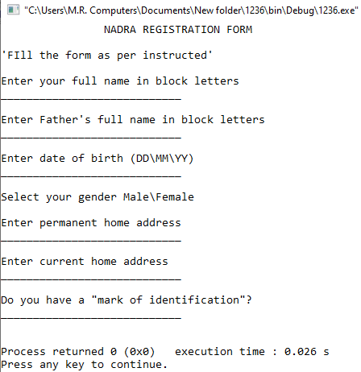

**2.2. Write a C++ program to illustrate “\r “escape sequence.**

**SOURCE CODE**

**#include <iostream>**

**using namespace std;**

**int main()**

**{**

**cout<<"nabeel rizwan quadri"<<endl;**

**cout<<"nabeel \rrizwan quadri"<<endl;**

**cout<<"nabeel rizwan \rquadri"<<endl;**

**cout<<"nabeel \r rizwan \rquadri"<<endl;**

**return 0;**

**}**

**OUTPUT**

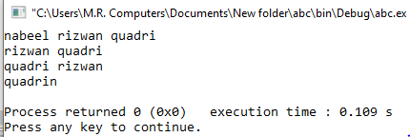

**2.3 Write a C++ program to illustrate \' escape sequence, \" escape sequence and \? Escape sequence.**

**SOURCE CODE**

**#include <iostream>**

**using namespace std;**

**int main()**

**{**

**cout<<"The news reporter, \"will they win the match\?\""<<endl;**

**cout<<"Misbah-ul-haq,\"The overall team is in good shape except for \'that one player\' but even he can perform well.\""<<endl;**

**return 0;**

**}**

**OUTPUT**

